CSC-203L Computer Network
Project Report
Multi-Campus University Network

Submitted by:
Abdul Moez 2024-SE-14
Umair Arshad 2024-SE-38
M. Zeeshan 2024-SE-13
Submitted to:
Sir Nouman
Dated: 9th January 2026

Department of Computer Science
University of Engineering and Technology Lahore, New Campus

Table of Contents
1. Abstract 3
2. Introduction 3
3. Devices Used 4
4. Network Diagram 5
5. VLAN And IP Addressing Table 5
5.1. Main Campus 5
5.1.1. CS Department 5
5.1.2. Electrical Department 6
5.1.3. Mechanical Department 7
5.2. New Campus 8
5.2.1. CS Department 8
5.2.2. Electrical Department 8
5.2.3. Mechanical Department 9
5.3. FSD Campus 10
5.3.1. CS Department 10
5.3.2. Electrical Department 10
5.3.3. Mechanical Department 11
6. Key Configuration 12
6.1. Switch Configuration 12
6.2. Router Configuration 12
6.2.1. Internal Routing 12
6.3. Router CLI 12
6.4. Server Configuration 13
7. Testing Results 14
7.1. Pinging 14
7.1.1. Ping Test (CS → EE) 14
7.2. Trace Route Trace route from one department to another department 14
8. Packet Simulation 15
9. Troubleshooting Commands Used 15
10. Redundancy And Failover Testing 15
11. Conclusion 15

Abstract
This project presents the design and implementation of a scalable, high-availability university network across multiple campus locations using Cisco Packet Tracer. The architecture features a central main campus and two sub-campuses, utilizing a star-shaped core topology for central connectivity while maintaining inter-campus communication via border routers. Within each sub-campus, the internal infrastructure is optimized using Layer 3 switches to handle inter-VLAN routing and local traffic, which are then linked to internal routers for departmental communication. To ensure efficient traffic management and security, the design employs VLANs for departmental isolation (Computer Science, Electrical Engineering, and Administration) and VLSM for optimized IPv4 addressing. Routing reliability is achieved through a hybrid protocol approach: OSPF manages internal campus traffic, while BGP is implemented on border routers to provide load balancing and redundancy for inter-campus and ISP connectivity. The final implementation is validated through comprehensive testing of end-to-end connectivity, server accessibility, and Access Control List (ACL) verification.

Introduction
Modern university environments require sophisticated network infrastructures that can seamlessly connect diverse departments across geographically dispersed sub-campuses while maintaining high performance and security. This project focuses on designing a multi-campus, requiring the implementation of a complex system that eliminates single points of failure.
The network design is structured around several critical architectural components:
- Hierarchical Topology: The main campus acts as a central hub, connecting to sub-campuses via a star-shaped design with border routers at each location to facilitate inter-campus communication and ISP connectivity.
- Internal Sub-Campus Architecture: Each sub-campus utilizes Layer 3 switches to perform high-speed inter-VLAN routing between departments. These switches connect to internal routers that handle routing between specific departmental units and the wider campus network.
- Departmental Segmentation: To optimize performance and security, departments such as Computer Science (VLAN 10), Electrical Engineering (VLAN 20), and Administration (VLAN 30) are isolated into separate VLANs.
- Efficient IP Management: The design uses VLSM (Variable Length Subnet Masking) within the 192.168.0.0/16 private IP range to ensure efficient address allocation across all subnets.
- Core Services: Each sub-campus supports essential services including Web (HTTP), Email, DNS, and FTP servers, with access controlled by ACLs to restrict or allow traffic based on departmental requirements.
By utilizing Cisco Packet Tracer, this project simulates a real-world enterprise environment. It provides a platform to verify routing functionality via OSPF and BGP, ensuring the network can handle failover scenarios and maintain connectivity between all departmental units across the university.

Devices Used
Device Type | Model Number | Where to Find
Border Router | 2911 | Routers → 2911
Internal Router | 2911 | Routers →2911
Layer 3 Switch | 3650-24PS | Switches → 3650-24PS
Access Switch | 2960-24TT | Switches → 2960-24TT

Network Diagram
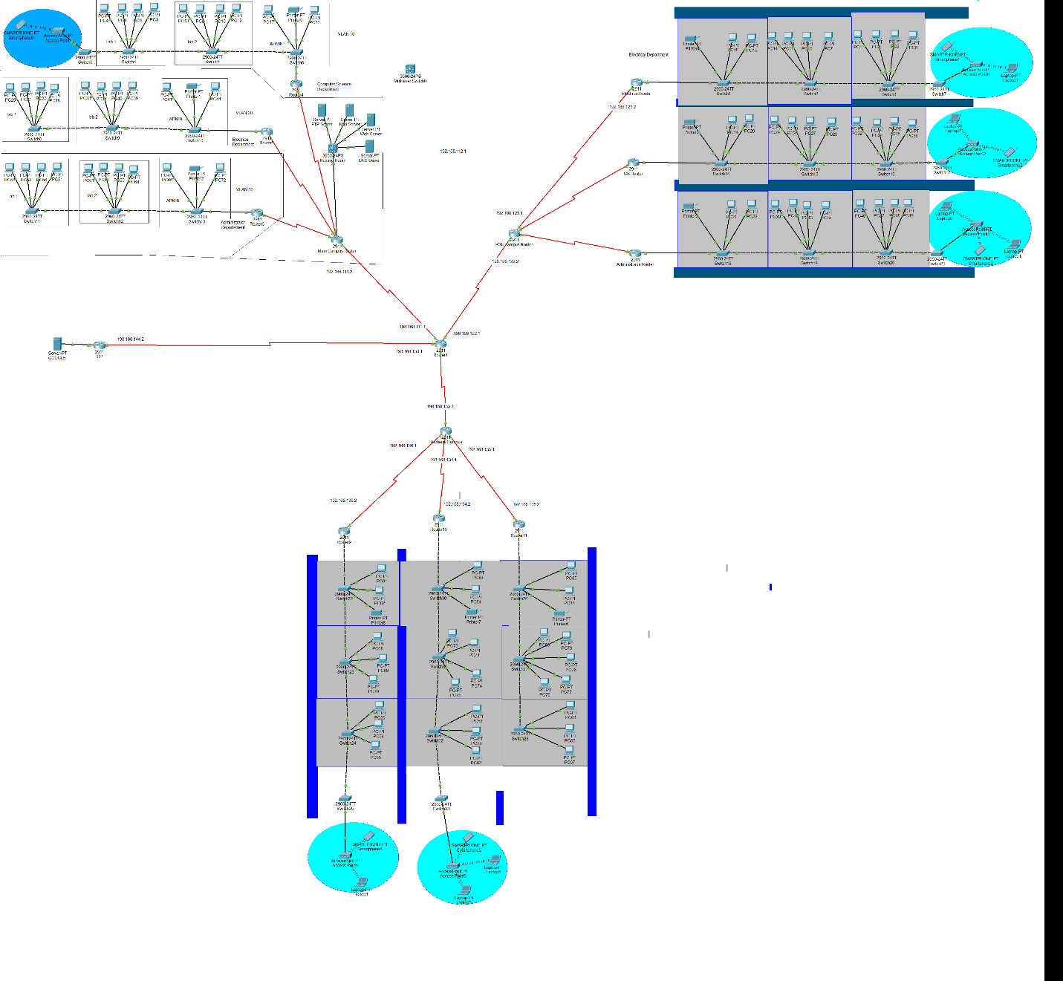

VLAN And IP Addressing Table

Main Campus

CS Department
Network Segment | Hosts Required | Hosts Available | Network Address | Subnet Mask | First Host | Last Host | Broadcast
VLAN 10  Admin | 50 | 62 (/26) | 192.168.1.0 | 255.255.255.192 | 192.168.1.1 | 192.168.1.62 | 192.168.1.63
VLAN 20  Lab 2  &  VLAN 20  Lab 1 | 40 | 62 (/26) | 192.168.1.64 | 255.255.255.192 | 192.168.1.65 | 192.168.1.126 | 192.168.1.127
VLAN 30 | 35 | 62 (/26) | 192.168.1.128 | 255.255.255.192 | 192.168.1.129 | 192.168.1.198 | 192.168.1.191
R4 to Main  Campus Router  Serial 0/0/0 | 2 | 2 (/30) | 192.168.100.0 | 255.255.255.252 | 192.168.100.1 | 192.168.100.2 | 192.168.100.3

Electrical Department
Network Segment | Hosts Required | Hosts Available | Network Address | Subnet Mask | First Host | Last Host | Broadcast
VLAN 10  Admin | 50 | 62 (/26) | 192.168.2.0 | 255.255.255.192 | 192.168.2.1 | 192.168.2.62 | 192.168.2.63
VLAN 20  Lab 2  &  VLAN 20  Lab 1 | 40 | 62 (/26) | 192.168.2.64 | 255.255.255.192 | 192.168.2.65 | 192.168.2.126 | 192.168.2.127
VLAN 30 | 35 | 62 (/26) | 192.168.2.128 | 255.255.255.192 | 192.168.2.129 | 192.168.2.198 | 192.168.2.191
R5 to Main  Campus Router  Serial 0/0/0 | 2 | 2 (/30) | 192.168.100.4 | 255.255.255.252 | 192.168.100.5 | 192.168.100.6 | 192.168.100.7

Mechanical Department
Network Segment | Hosts Required | Hosts Available | Network Address | Subnet Mask | First Host | Last Host | Broadcast
VLAN 10  Admin | 50 | 62 (/26) | 192.168.3.0 | 255.255.255.192 | 192.168.3.1 | 192.168.3.62 | 192.168.3.63
VLAN 20  Lab 2  &  VLAN 20  Lab 1 | 40 | 62 (/26) | 192.168.3.64 | 255.255.255.192 | 192.168.3.65 | 192.168.3.126 | 192.168.3.127
VLAN 30 | 35 | 62 (/26) | 192.168.3.128 | 255.255.255.192 | 192.168.3.129 | 192.168.3.198 | 192.168.3.191
R6 to Main  Campus Router  Serial 0/0/0 | 2 | 2 (/30) | 192.168.100.8 | 255.255.255.252 | 192.168.100.9 | 192.168.100.10 | 192.168.100.11

New Campus

CS Department
Network Segment | Hosts Required | Hosts Available | Network Address | Subnet Mask | First Host | Last Host | Broadcast
VLAN 10  Admin | 50 | 62 (/26) | 192.168.10.0 | 255.255.255.192 | 192.168.10.1 | 192.168.10.62 | 192.168.10.63
VLAN 20  Lab 2  &  VLAN 20  Lab 1 | 40 | 62 (/26) | 192.168.10.64 | 255.255.255.192 | 192.168.10.65 | 192.168.10.126 | 192.168.10.127
VLAN 30 | 35 | 62 (/26) | 192.168.10.128 | 255.255.255.192 | 192.168.10.129 | 192.168.10.198 | 192.168.10.191
R4 to Main  Campus Router  Serial 0/0/0 | 2 | 2 (/30) | 10.0.0.0 | 255.255.255.252 | 10.0.0.1 | 10.0.0.2 | 10.0.0.3

Electrical Department
Network Segment | Hosts Required | Hosts Available | Network Address | Subnet Mask | First Host | Last Host | Broadcast
VLAN 10  Admin | 50 | 62 (/26) | 192.168.20.0 | 255.255.255.192 | 192.168.20.1 | 192.168.20.62 | 192.168.20.63
VLAN 20  Lab 2  &  VLAN 20  Lab 1 | 40 | 62 (/26) | 192.168.20.64 | 255.255.255.192 | 192.168.20.65 | 192.168.20.126 | 192.168.20.127
VLAN 30 | 35 | 62 (/26) | 192.168.20.128 | 255.255.255.192 | 192.168.20.129 | 192.168.20.198 | 192.168.20.191
R4 to Main  Campus Router  Serial 0/0/0 | 2 | 2 (/30) | 10.0.0.4 | 255.255.255.252 | 10.0.0.5 | 10.0.0.6 | 10.0.0.7

Mechanical Department
Network Segment | Hosts Required | Hosts Available | Network Address | Subnet Mask | First Host | Last Host | Broadcast
VLAN 10  Admin | 50 | 62 (/26) | 192.168.30.0 | 255.255.255.192 | 192.168.30.1 | 192.168.30.62 | 192.168.30.63
VLAN 20  Lab 2  &  VLAN 20  Lab 1 | 40 | 62 (/26) | 192.168.30.64 | 255.255.255.192 | 192.168.30.65 | 192.168.30.126 | 192.168.30.127
VLAN 30 | 35 | 62 (/26) | 192.168.30.128 | 255.255.255.192 | 192.168.30.129 | 192.168.30.198 | 192.168.30.191
R4 to Main  Campus Router  Serial 0/0/0 | 2 | 2 (/30) | 10.0.0.8 | 255.255.255.252 | 10.0.0.9 | 10.0.0.10 | 10.0.0.11

FSD Campus

CS Department
Network Segment | Hosts Required | Hosts Available | Network Address | Subnet Mask | First Host | Last Host | Broadcast
VLAN 10  Admin | 50 | 62 (/26) | 192.168.60.0 | 255.255.255.192 | 192.168.60.1 | 192.168.60.62 | 192.168.60.63
VLAN 20  Lab 2  &  VLAN 20  Lab 1 | 40 | 62 (/26) | 192.168.60.64 | 255.255.255.192 | 192.168.60.65 | 192.168.60.126 | 192.168.60.127
VLAN 30 | 35 | 62 (/26) | 192.168.60.128 | 255.255.255.192 | 192.168.60.129 | 192.168.60.198 | 192.168.60.191
R4 to Main  Campus Router  Serial 0/0/0 | 2 | 2 (/30) | 12.0.0.0 | 255.255.255.252 | 12.0.0.1 | 12.0.0.2 | 12.0.0.3

Electrical Department
Network Segment | Hosts Required | Hosts Available | Network Address | Subnet Mask | First Host | Last Host | Broadcast
VLAN 10  Admin | 50 | 62 (/26) | 192.168.70.0 | 255.255.255.192 | 192.168.70.1 | 192.168.70.62 | 192.168.70.63
VLAN 20  Lab 2  &  VLAN 20  Lab 1 | 40 | 62 (/26) | 192.168.70.64 | 255.255.255.192 | 192.168.70.65 | 192.168.70.126 | 192.168.70.127
VLAN 30 | 35 | 62 (/26) | 192.168.70.128 | 255.255.255.192 | 192.168.70.129 | 192.168.70.198 | 192.168.70.191
R4 to Main  Campus Router  Serial 0/0/0 | 2 | 2 (/30) | 12.0.0.4 | 255.255.255.252 | 12.0.0.5 | 12.0.0.6 | 12.0.0.7

Mechanical Department
Network Segment | Hosts Required | Hosts Available | Network Address | Subnet Mask | First Host | Last Host | Broadcast
VLAN 10  Admin | 50 | 62 (/26) | 192.168.80.0 | 255.255.255.192 | 192.168.80.1 | 192.168.80.62 | 192.168.80.63
VLAN 20  Lab 2  &  VLAN 20  Lab 1 | 40 | 62 (/26) | 192.168.80.64 | 255.255.255.192 | 192.168.80.65 | 192.168.80.126 | 192.168.80.127
VLAN 30 | 35 | 62 (/26) | 192.168.80.128 | 255.255.255.192 | 192.168.80.129 | 192.168.80.198 | 192.168.80.191
R4 to Main  Campus Router  Serial 0/0/0 | 2 | 2 (/30) | 12.0.0.8 | 255.255.255.252 | 12.0.0.9 | 12.0.0.10 | 12.0.0.11

Key Configuration

Switch Configuration
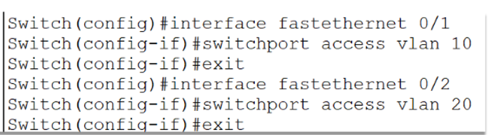

Router Configuration

Internal Routing
- OSPF used between:
- Internal routers
- Layer 3 switches
Rule | Description
ACL1 | Block Admin (Sub-Campus 3) from accessing CS Web Server
ACL 2 | Allow all departments to access Email Server
ACL 3 | Restrict inter-department access where required

Router CLI
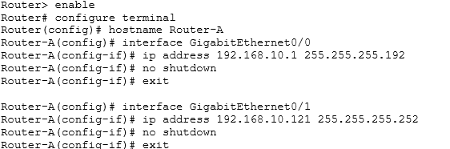

Server Configuration
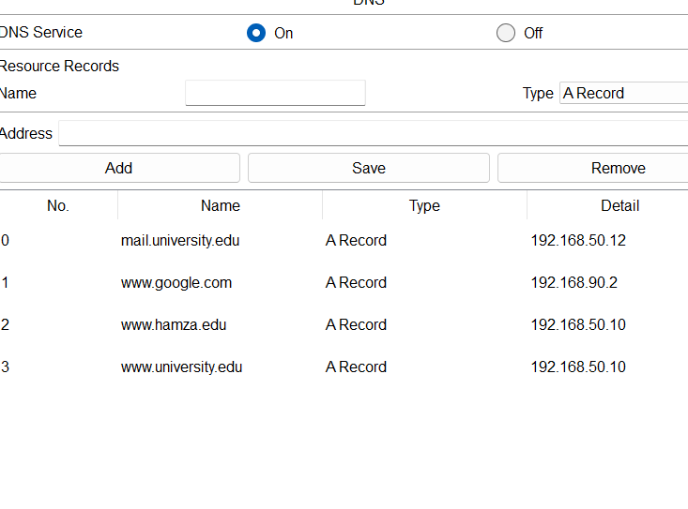

Testing Results

Pinging

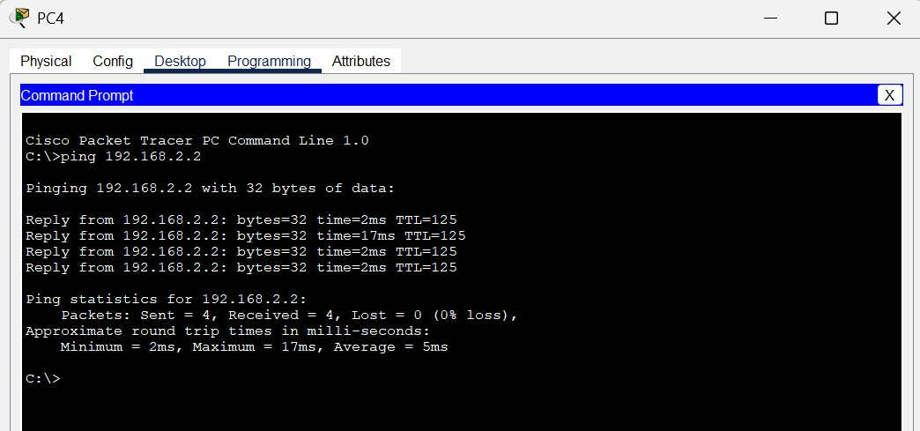
Ping Test (CS → EE)

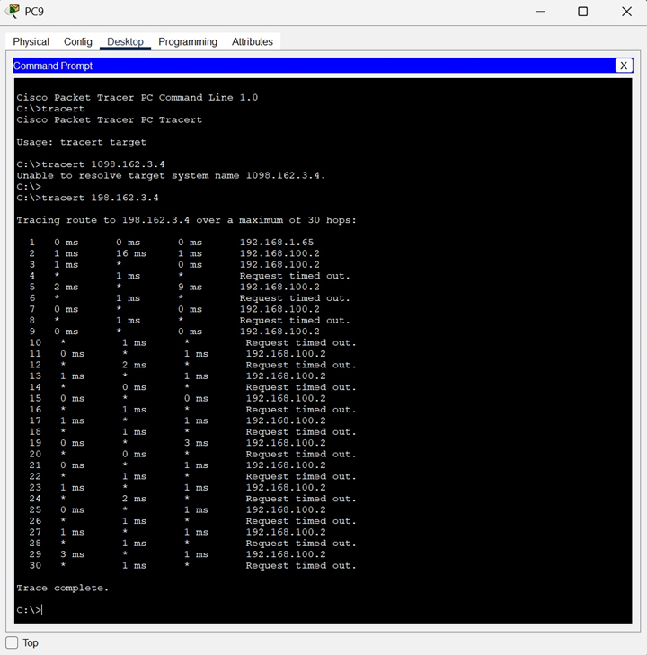
Trace Route
Trace route from one department to another department

Packet Simulation
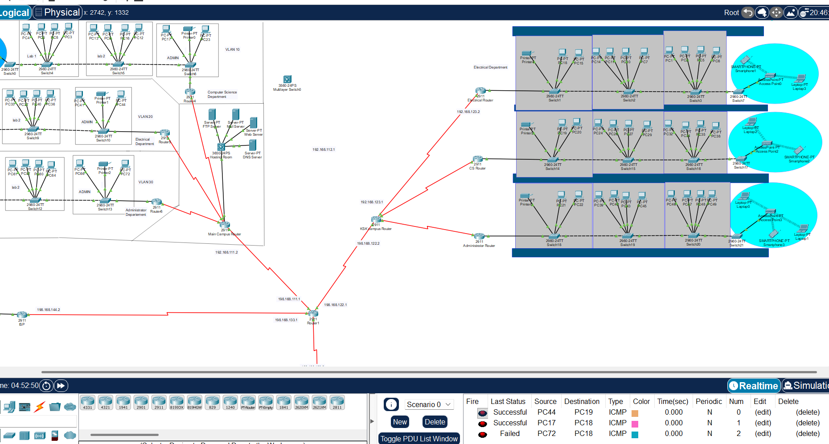

Troubleshooting Commands Used
- ping
- tracert
- show ip route
- show vlan brief
- show ip ospf neighbor
- show ip bgp summary

Redundancy And Failover Testing
- Border router shutdown tested
- Traffic successfully rerouted via alternate border router
- No loss of connectivity observed

Conclusion
The designed network successfully meets all requirements of the CSC203L Open Ended Lab. The project demonstrates effective use of VLANs, VLSM-based IP addressing, dynamic routing protocols (OSPF & BGP), ACL-based security, and redundancy through multiple border routers. All test cases were validated, ensuring reliable and secure inter-campus communication.

